The 9th International Conference on Microelectronics and Plasma Technology (16pt, Centered, Bold)

Gil-Dong Hong¹ and Gwan-Sun Yu^{2*} (11pt, Centered)

¹Seoul National University, Republic of Korea (11pt, Centered),
²Sungkyunkwan University, Republic of Korea
*Corresponding Author e-mail: abc@skku.edu

The 9th International Conference on Microelectronics and Plasma Technology (ICMAP 2024) will be held in Booyoung Hotel & Resort, Jeju, Republic of Korea, during January 15-18, 2024. Authors are invited to contribute original presentations on advances in Microelectronics and Plasma Technology.

ICMAP 2024 Local Organizing Committee encourages the submission of original works for either oral or poster presentation. You are required to submit abstract via online abstract submission system.

The purpose of an abstract is what new results you propose to present. Therefore, it is important within the first few sentences to state what your primary result is. After presentation of results, it is useful to compare specific results with related work, and also to comment on the broader impact of the results.

The abstract should be typewritten for A4 format paper, minimum of 200 words (with space). Please respect the margins! (Margins: Top: 3 cm, Bottom: 2.5 cm; Left and Right: 2 cm)

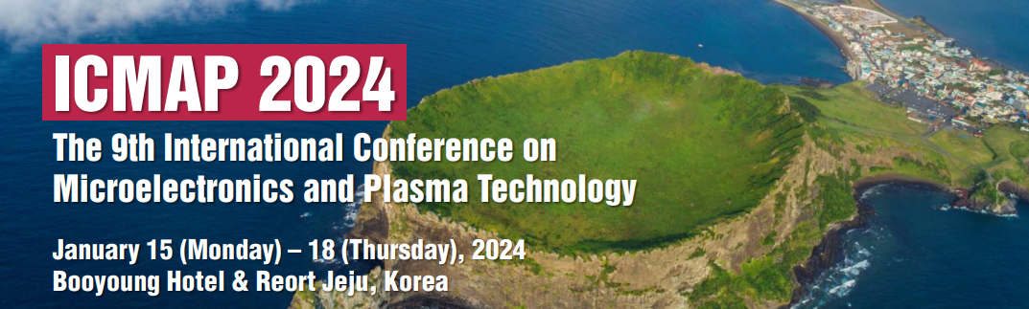
Fig. 1 ICMAP 2024

Abstract may include figures and photographs. A caption should be attached to each figure. (Caption style: Fig. 1. Your text) Please make sure that all the figures/photographs are clearly visible. If Local Organizing Committee cannot clearly see and understand these visual aids, abstract will not be properly evaluated. All submitted abstracts will be considered for both oral and poster presentations unless the author specifically requests poster presentation.

References:
[1]T. First Author, Book Name, Place Published, pp 825-830, 2017.
[2]T. First Author, “Paper Title”, The Journal/Proceedings Name, Vol. 9, pp 825-830, year 2017.

Acknowledgement:
This work was supported by ABC program.

